Observation Feedback Form

Teacher’s Name | Erica Guardino |  | Date | February 19, 2016 |  |  | Time | 900 |  | to | 1025
Subject/Grade | Psychology |  | Class Observed |  | AM Block-A Day
School Name | Green High School | Employee ID Number

Observations
Sociology - February 19, 2016 GRHS Room 117

Classroom Environment:
27 students (8 males, 19 female) present.
Chairs arranged in flexible groupings of 4 desks facing each other.
Lesson Plan provided to observer. Learning Target on a large, pink sticky note on the left chalkboard. Sociology " I can describe the family systems and functions, families in the US, and recent trends in marriage & family." Psychology "I can explain motivation as a function of needs and drives."

855-901
Green Run video broadcast morning announcements: students stand for pledge, moment of silence, and view announcements.

901-907
Teacher displays Journal Question "What is the biggest problem facing families today?" on Promethean whiteboard, which students answer electronically. Teacher passes out an answer cards for Plicker Game.

907-911
Teacher gives directions for listening to podcast regarding the Columbine Shooting. Teacher introduces and previews questions with students.

911-931
Students listen to NPR podcast. Teacher stops periodically to add background information (first mass shooting by teenagers at a public high school, etc.)

931-948
In whoile group debrief, a few students offer opinions and reactions. Teacher informs students they have 15 minutes to compose their letter to Mrs. Klebold (one of the shooters' mothers). Teacher circulates room as students work. As students complete their writing, they sit quietly as others finish. Observer circulates the room to ask students to explain their reaction to podcast/ Columbineevent.

948-950
Timer goes off and teacher collects letters. All but two students have completed their work.

950-955
Teacher explains how Plickers work and pulls up game on Promethean board.

955- 1024
Plicker review game is played.
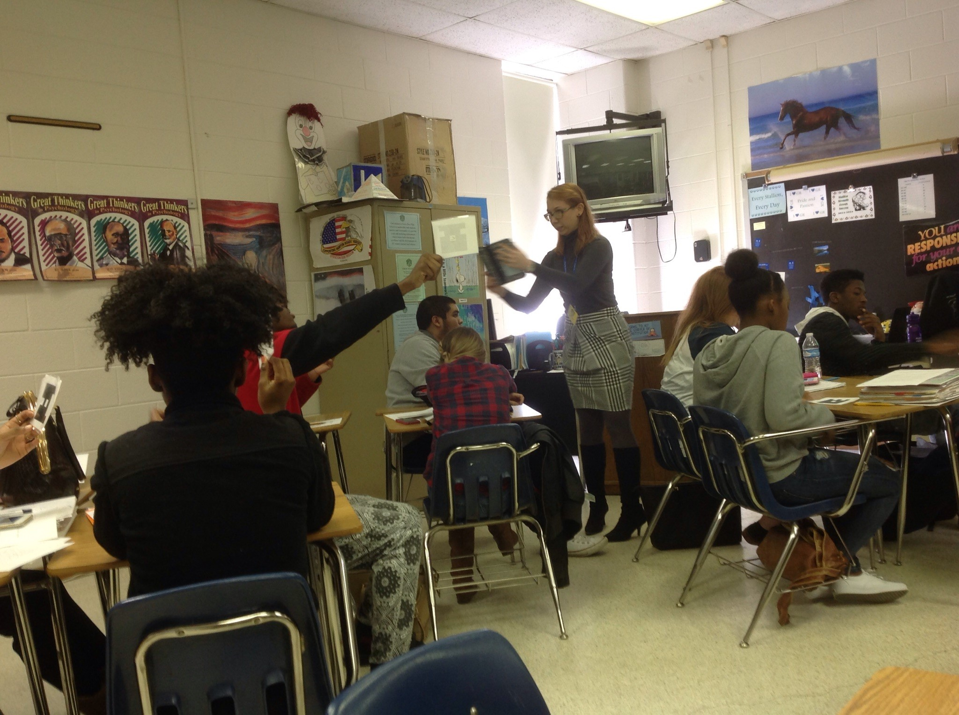

1025 Class dismissed, observation ends.
Feedback
Reinforcements
* Smooth and purposeful incorporation of technology.
* Positive rapport with students; students both compliant and engaged.

Reflections/Questions to Think About
* How could peer conversations deepen learning? For example, allow students to write their letter for 10 minutes, discuss with their group members for 5 minutes, and return to letter to add further thoughts or to refine writing.
*How can a defined closure activity at the end of class (last 5-7 minutes) help us to assess student learning for the day?

Post-Observation Conference: Immediately after class ended.
ODU checklist form completed with student teacher. (See next page)

Lisa Gibson____________ Instructional Specialist, Social Studies 2/19/16
Signature of Observer Title Date

Signature of Teacher Title Date
* Signature indicates knowledge of the Observation Feedback Form, not agreement with any items contained within.
2-3



